Intelligent Recognition of Multimodal Human Activities for Personal Healthcare

Abstract
In today’s digitally connected healthcare landscape, the integration of IoT devices with intelligent machine learning techniques has become an essential approach for enhancing patient care and monitoring. Traditional patient monitoring systems relied heavily on the manual supervision of medical staff, which was time-consuming, labour-intensive, and prone to human error. The advent of IoT and AI has revolutionized this domain by introducing real-time, automated monitoring systems that operate efficiently and accurately. In this project, we introduce a hybrid deep learning-based patient activity recognition system that leverages multimodal IoT data for accurate and real-time monitoring. The system uses wearable sensors such as gyroscopes and accelerometers embedded in patients' bodies to capture movement data, which is then fed into a hybrid model consisting of Extreme Learning Machine (ELM), Gated Recurrent Unit (GRU), and Attention Mechanism (AM). ELM is first employed to extract and transform relevant features from the input data. These transformed features are then processed through the attention layer, which assigns appropriate weights to focus on the most critical information. The final prediction is made using GRU, a recurrent neural network variant capable of capturing sequential dependencies. This hybrid model enhances the performance of activity recognition systems and achieves an accuracy of up to 96%, outperforming existing methods like Random Forest, CNN, and LSTM, which range between 89% and 91%. The model is trained and evaluated using the KUHAR multimodal dataset, which contains labelled activity data. The system is implemented in a web-based application that includes modules for user registration, login, dataset loading, training and testing of models, and real-time activity recognition. This work contributes significantly to the healthcare monitoring domain by offering a more intelligent, automated, and reliable solution for understanding patient behaviour and supporting timely medical interventions.
Keywords:
IoT, Patient Activity Recognition, Extreme Learning Machine (ELM), Gated Recurrent Unit (GRU), Attention Mechanism (AM), Healthcare Monitoring.

Existing system
The existing systems for patient activity monitoring primarily rely on conventional machine learning and standalone deep learning models like Random Forest, CNN, and LSTM. These models work effectively with basic sensor inputs but are limited by their inability to handle multimodal data efficiently. Moreover, they often fail to prioritize important data points, leading to lower accuracy and less reliable recognition in dynamic and noisy healthcare environments.
Disadvantages:
- Limited accuracy due to use of single-model architectures.
- Inability to process or prioritize important features in real-time.
- Struggles with complex, multimodal sensor data from healthcare environments.
Proposed system
The proposed system utilizes a hybrid deep learning framework combining ELM, GRU, and an Attention Mechanism to enhance the performance of activity recognition using multimodal IoT sensor data. ELM is used for fast and efficient feature extraction, the Attention Mechanism helps in emphasizing significant features, and GRU handles time-series modeling. This hybrid approach improves recognition accuracy and makes the system suitable for real-time healthcare applications.
Advantages:
- Achieves high accuracy (96%) through hybrid ELM-GRU-AM architecture.
- Effectively processes multimodal IoT data using feature prioritization.
- Suitable for real-time, automated patient monitoring in dynamic environments.
Modules Description:
To implement this project, we have designed following modules
- New User Register: user can sign up with the application
- User Login: user can login to system
- Load & Process Kuhar Dataset: using this model will load and process all Kuhar dataset and then split into train and test where application using 80% records for training and 20% for testing. This module responsible to apply ELM on processed data to collect relevant features
- Run Existing & ELM-GRUAM Models: 80% training records will be input to all existing and propose algorithms to trained a model and this model will be applied on 20% test data to calculate prediction accuracy
- Activity Recognition: using this module user can upload test data and then ELM will be applied to transform features and then GRU with attention model will be applied to recognize activities from test data

System Architecture:
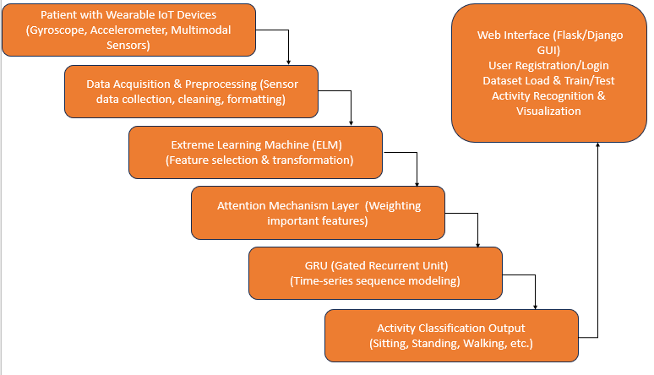

HARDWARE & SOFTWARE REQUIREMENTS:
HARDWARE REQUIRMENTS:
- Processor : Intel I3 (min)
- Hard Disk : 500 GB (min).
- Ram : 4 GB (min).
SOFTWARE REQUIRMENTS:
- Operating system : Windows 10 (min)
- Coding Language : python 3.7.2 with django

